Continental Lambert Azimuthal Equal Area (CLAEA) Prototype Products
Objectives:
- Demonstrate that production system can implement CLAEA
- Cover the globe fully (one time) to allow review of effects at any WRS-2 path/row
- Allow for technical review and feedback on the implementation
Limitations:
- The prototype products do not introduce any other anticipated Collection 3 features (e.g., changes to pixel sizing or indexing) – they are simply “Collection 2 spec” but in CLAEA instead of UTM
- No time series is provided
Projections specifications:
https://epsg.org/home.html
Zone​ | Center Longitude​ | Center Latitude​ | EPSG Code​
Africa​ (AF) | 20​ | 5​ | 10592​
Antarctica​ (AN) | 0​ | -90​ | 6932​
Asia​ (AS) | 100​ | 45​ | 10594​
Europe​ (EU) | 20​ | 55​ | 10596​
Oceana​ (OC) | 135​ | -15​ | 10601​
North America​ (NA) | -100​ | 50​ | 10598​
South America​ (SA) | -60​ | -15​ | 10603​

References:
Snyder (1987). Map projections: A working manual. https://pubs.usgs.gov/publication/pp1395
Brodzik et al. (2012). EASE-Grid 2.0: Incremental but Significant Improvements for Earth-Gridded Data Sets. https://doi.org/10.3390/ijgi1010032
Bauer-Marschallinger et al. (2014). Optimisation of global grids for high-resolution remote sensing data. https://doi.org/10.1016/j.cageo.2014.07.005
https://measures-glance.github.io/glance-grids/

Access:
https://dds.cr.usgs.gov/samples/c3_global_sample/
Prototype products are organized by zone as follows
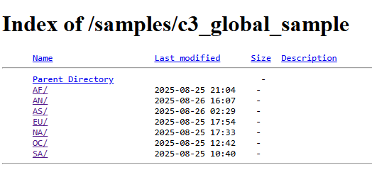
Other notes:
- In filenames, the Collection version indicator “02” is replaced with “99” to designate that these products are in a prototype state.
- In filenames, a continental zone code has been added (e.g., “NA” for scenes covering the North America zone).
- DataReviewChecklist_20260226.doc is provided as a general guide to common items for review in data evaluations. It’s just for reference; you are free to focus on whatever assessments are of interest to you.
- We do not plan on tiling any data in Collection 3

Visualizations:
- WRS-2 coverage and Tissot’s Indicatrix by Zone
